**Unit 4 Linking Ideas; Writing a Conclusion**

**Getting Taking Organising Linking ideas notes ideas ideas**

**Referencing Academic**

**style**

**Writing**

**Revising a final draft**

**The writing process**

# Session 1

*In this session you will learn how to do the following:*

* Connect ideas within a paragraph
* Structure paragraphs in an essay

**Activity 1: Learning about paragraph structure**

1. *A student, Mithila, has some questions about paragraphs.*

* How long is a paragraph?
* When I write academic essays, do I always have to write in paragraphs?
* Is there a special way to organise my ideas in a paragraph?

*Read the text below and underline the key information to find answers to Mithila’s questions.*

Using paragraphs is essential when you write an essay as this helps you organise your ideas clearly. A paragraph consists of three major structural sections: a topic sentence, supporting sentences and a concluding sentence. The **topic sentence\*** is responsible for stating the main idea of the paragraph. It informs the readers what the paragraph is about. This is usually the first sentence of the paragraph. All the other sentences in the paragraph are connected to the topic sentence. The main idea stated in the topic sentence is developed by the **supporting sentences\***. By providing facts, figures, examples, quotes, information and reasons, supporting sentences elaborate the topic sentence. The **concluding sentence\*** indicates the end of a paragraph and leaves the reader with key points to remember or leads into the next paragraph. Remember, each paragraph should contain one main idea only. There is no hard and fast rule about the length of a paragraph, but it should be long enough to develop the main idea clearly.

1. *Can you find the topic sentence, supporting sentences and concluding sentence in this paragraph? Mark them on the paragraph.*

Figures 1 & 2 Jute plants (left) and extraction of jute from stems (right) Source: <http://en.wikipedia.org/wiki/Jute>

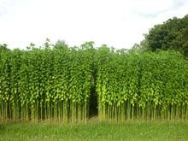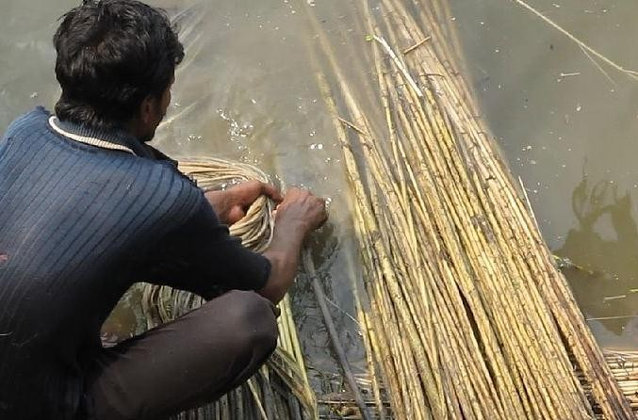

Bangladeshi scientists decoded the genome of the jute plant opening up a new horizon in the development of the variety of the golden fibre of Bangladesh. Hawaii-based Bangladeshi scientist Professor Maqsudul Alam led a group of Bangladeshi researchers to this landmark discovery. Dr. Alam said of this research, “This is a great accomplishment not only for Bangladesh but for the whole world”. The fungus known as *Macrophominaphaseolina* is responsible for 500 plant diseases across the world. Not only jute but many other plants such as soybean, cotton, tobacco and maize are affected by this dangerous fungus. Now, after the successful sequencing of jute fibre by the Bangladeshi researchers, length, quality as well as colour and strength of jute fibre will be better. The successful sequencing of jute genome is a major achievement for Bangladesh.

Text source: (Adapted from) *Jute Genome decoded*, The Daily Star (June 2010)

[*http://archive.thedailystar.net/newDesign/news-details.php?nid=143047*](http://archive.thedailystar.net/newDesign/news-details.php?nid=143047)

1. *Read the paragraph that follows.*
   1. What is the topic of the paragraph?
   2. Can you add a suitable topic sentence to the beginning of the paragraph?

He must eat what is food and not poison. He must live in a residence that is reasonably equipped to afford him protection from the elements. For all these he must know the nature of the things he absorbs. This he can do only by having the necessary knowledge of nature of which these are products. In other words, he must know the laws of nature.

# Activity 2: Paragraph structure – can you find it?

*The sentences below make up a paragraph although they are currently mixed up. Find the topic sentence, supporting sentences and concluding sentence and complete the table to reorder.*

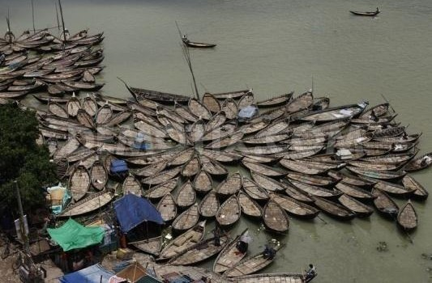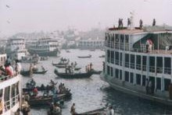

**Environmental problems in Bangladesh: River pollution**

(a) Moreover, groups and individuals have found ways to generate income by illegally constructing houses and factories along the Buriganga. (b) The river is seriously afflicted by pollution. (c) As a result, the Buriganga River is dying biologically and hydrologically. (d) There are mainly three types of discharges

– industrial discharge, boat fuel discharge and household garbage. (e) These threats stem from discharging industrial wastes and household garbage into the river. (f) While all the rivers of Bangladesh are threatened by climate change, the Buriganga in particular is struggling against more direct human threats.

Figures 1 & 2: boats on the river (left); steamers (right

Source: (left) [http://www.demotix.com/news/5420624/bangladeshi-boatmen-passing-idle-time-post-eid-](http://www.demotix.com/news/5420624/bangladeshi-boatmen-passing-idle-time-post-eid-vacation#media-5420215) [vacation#media-5420215](http://www.demotix.com/news/5420624/bangladeshi-boatmen-passing-idle-time-post-eid-vacation#media-5420215);( right) <http://upload.wikimedia.org/wikipedia/commons>

Text source: (Adapted from) Buriganga River Keeper (2013). *The Buriganga River,* [http://www.burigangariverkeeper.com/index.php?option=com_content&view=article&id=6](http://www.burigangariverkeeper.com/index.php?option=com_content&amp;view=article&amp;id=6) 0&Itemid=69

|  |  |  |  |  |  |  |
| --- | --- | --- | --- | --- | --- | --- |
| *Order* | *1* | *2* | *3* | *4* | *5* | *6* |
| *Sentence* |  | *b* |  |  |  |  |

**Study tip**

Topic Sentence = Topic + Controlling Idea

*E.g.* While all the rivers of Bangladesh are threatened by climate change, the Buriganga in particular is struggling against more direct human threats.

(Topic) (Controlling Idea)

# Activity 3: Cohesive devices

You can use cohesive devices* inside a paragraph to add and connect information, to stress a fact, to indicate change of topic or to conclude a matter. Here are some examples:

|  |  |  |
| --- | --- | --- |
| **To reinforce and add information** | **To signal a change in ideas** | **To signal a conclusion** |
| also | but | thus |
| in other words | on the other hand | in conclusion |
| in addition | however | therefore |
| for example | nevertheless | accordingly |
| more importantly | instead | finally |
| …………………………… | yet | ………………………….. |
|  | in contrast |  |
|  | although |  |
|  | in spite of [something] |  |
|  | ………………………………… |  |

1. *Look back at the paragraph in Activity 2. Which cohesive devices did the writer use? Add them to the correct column in the table*
2. *Circle any words in the table which are new to you. Discuss their meaning and use with a partner.*
3. *Make a note of the new words you will try to use in your next writing.*

# Activity 4: Can you write a well-structured paragraph?

*In Activity 2 you read about the problems of water pollution in Bangladesh. Now write a paragraph about a different environmental problem which is affecting the area where you live. You can use the ideas in the box to help you.*

Soil degradation Emission from vehicles Deforestation

Noise pollution

Air pollution Industrial discharge

**Environmental problems in Bangladesh**

1. *Structure your paragraph so that it has a topic sentence, supporting sentences and a concluding sentence.*
2. *Use cohesive devices to connect ideas within the paragraph*.

*Work with a partner. Evaluate each other’s paragraph.*

# Extension: Using cohesive devices

*Work in pairs. Read the text that follows. Fill in each gap with a suitable cohesive device. Sometimes more than one correct answer is possible. (You can use the words from the table in Activity 3 to help you).*

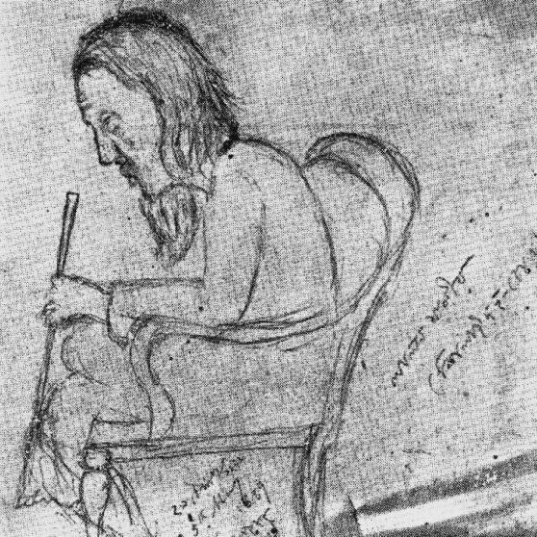

**Baul Song**

Baul song, a form of folk music, has had a tremendous influence on the music of Bangladesh. Bauls use very simple words, (1) they express profound thoughts about life, creation, death and human emotions. They

1. use very simple musical instruments. Among the Bauls, Fakir Lalan Shah is the most

prominent figure. He was a mystic poet, saint and a reformer, but

1. , he was the composer and singer of many famous Baul songs now known as *Lalangeeti*. Lalan’s song was about the philosophy of spirituality, love and wisdom which attracted many people. Rabindranath Tagore, (4) , was directly influenced by Lalan’s ideals.

(5) it can be said that (6) urbanisation and westernisation have disrupted the easy lifestyle of the Bauls, they still charm us with simple lyrics, melodious tunes and the deep inner thoughts of their songs.

Figure 1 Fakir Lalan Shah (Source:http://commons.wikimedia.org/wiki/File:Fakir

_Lalon_Shah.jpg)

# Home task

* 1. Portfolio task

*In the previous session Home task you wrote the introduction for your essay title. Now write two body paragraphs for your essay. Remember to:*

* + 1. *Structure your paragraphs so that each paragraph has a topic sentence, supporting sentences and a concluding sentence.*
    2. *Use cohesive devices to connect ideas within the paragraphs*. *Add your completed paragraphs to your portfolio.*

# Unit 4 Linking Ideas; Writing a Conclusion

**Getting Taking Organising Linking ideas notes ideas ideas**

**Referencing Academic**

**style**

**Writing**

**Revising a final draft**

**The writing process**

**Session 2**

*In this session you will learn how to do the following:*

* Develop paragraphs thematically
* Write a conclusion

In Session 1 you learnt about structuring a paragraph. As you found out, every paragraph develops one topic or idea. Then the paragraphs must link together to develop the theme of the essay. One important thing to keep in mind is that there should be smooth transitions between the paragraphs.

# Activity 1: Paragraph theme and division

*Work in pairs:*

1. *In which of the following sectors do you think the situation of women has improved in Bangladesh? Put a tick mark (√) to indicate your preference.* o *Education*
   * *Health*
   * *Local work opportunities*
   * *Overseas work opportunities*
   * *Respect in society*
   * *Respect in the family*
   * *National politics*
2. *Now read the following text carefully. It’s about women’s empowerment in Bangladesh. There are four paragraphs (A, B, C and D) in this text. The paragraphs are currently in the wrong order.*
3. *Put them in the right order. What helps you to come to your decision?*

|  |  |  |  |  |  |  |  |  |
| --- | --- | --- | --- | --- | --- | --- | --- | --- |
| P1. |  | P2. |  | P3. | |  | P4. |  |
| **Women’s empowerment in Bangladesh**  A  In contrast to their striking gains in economic opportunities, Bangladeshi women in general have not done very well with respect to participation in national politics. Only 17 women contested and won general seats in the last parliamentary election in 2008 – and this is the highest figure to date.  B  As Bangladesh turns 40, improvements in women’s wellbeing and increased participation are some of the most significant gains. Various economic and social development indicators show that in the past 20 years, Bangladesh has made good progress in increasing women’s access to some important sectors.  C | | | | | | | | |
| Like the civic opportunity sector, Bangladesh does not have much to celebrate in terms of gender-related human development compared to many competitor countries. However, the pace of change merits attention as Bangladesh has come to this point from a very low starting point. There have been rapid  positive changes in Bangladeshi women’s | | | | |  | | | |
| health and education opportunities.  Figure 1 Women garment workers Source:  D http://en.wikipedia.org/wiki/File:Germents_  worker_Bangladesh.jpg  A key area where the situation for women in | | | | | | | | |
| Bangladesh has improved significantly is economic participation. One interesting recent development has been the sharp increase in women’s employment wage which has risen 4.3 percent between 2000 and 2005. Another factor that has  promoted women’s economic development has been microcredit. Bangladeshi women’s collective participation in microfinance programmes has been  unprecedented. Moreover, over two million women are employed in the garments manufacturing sector.  Text source: (Adapted from) Hossain, N., Nazneen, S. and Sultan, M. (2011) *National discourses on women empowerment in Bangladesh: continuities and change*, *IDS Working Paper 268*,<http://dspace.bracu.ac.bd/bitstream/handle/10361/1532/BDI%20Working%20Paper%20III->  %20Discources%20of%20Women's%20Empowerment.pdf?sequence=1 | | | | | | | | |

1. *Underline the thesis statement in the introduction and the topic sentences in the body paragraphs.*
2. *Discuss in pairs.* According to the text, in which sectors has the situation of women improved in Bangladesh? Do you agree with the author’s view?

# Activity 2: Cohesive* devices between paragraphs

As well as using cohesive devices to link ideas within a paragraph, you can also use cohesive devices to link paragraphs. Here are some examples of phrases you can use to indicate that a new paragraph has begun or a new idea has been introduced:

The main issue /chief factor is … A key area …

Another factor… Moreover,

...must also be examined In contrast to…

Turning to the issue of … On the other hand…

There are many advantages of…

1. *Discuss in a small group. Which of these phrases are you familiar with? Can you suggest any other useful phrases you can use to link paragraphs?*
2. *Look back at the text in Activity 1. Write down the phrases the writer has used to indicate that a new paragraph has begun or a new idea has been introduced.*

# Activity 3: Making a good ending





The conclusion is the finale of your essay. It should show you have reached the end of your discussion and that you have fully answered the essay question. Depending on the purpose of the essay, it may offer some recommendations or make some predictions.

* 1. *Discuss in pairs:*

**Study Tip**

A conclusion:

* is not too long
* never contains new ideas

You discovered in Unit 3 that introductions follow a logical order:

from general to specific information. What about conclusions? Does a conclusion order information in a particular way?

* 1. *Order the following statements to create a possible structure for a conclusion.*
     1. Offer some recommendations/ Make some predictions based on the points in your essay.
     2. Link to the thesis statement in your introduction
     3. Draw some conclusions based on the points in your essay
     4. Refer back to the essay title
     5. Recap briefly the main ideas of the essay

|  |  |  |  |  |  |
| --- | --- | --- | --- | --- | --- |
| Order |  |  |  |  |  |

*Share your response with the class.*

# Activity 4: Writing a conclusion

*Work in groups. Reread the text on empowerment of Bangladeshi women in Activity 1. There is an introductory paragraph and three body paragraphs. Write a conclusion.*

Conclusion:

# Extension: Structuring a conclusion

1. *In Unit 3 Session 2 Activity 4, Abid was writing an essay about Global warming:*

Impact of global warming on developing countries like Bangladesh

*Here is Abid’s conclusion, but it is not very well ordered. Order the sentences to make a more effective conclusion. Use the information from Activity 3 to help you.*

1. Therefore, the government and people of Bangladesh need to take measures to limit these effects as much as possible, for example recycling more, reducing waste and lowering electricity consumption.
2. In conclusion, the impact of global warming on developing countries, such as Bangladesh, is of major concern.
3. However, Bangladesh cannot solve this problem alone; this is an international issue and rich industrialised nations who have been largely responsible for causing global warming need to take a bigger responsibility to

support developing countries in dealing with its effects by providing financial and technological support.

1. As the essay has shown, the damaging effects of global warming on people’s health, wealth and living environment in Bangladesh are significant and continuing to grow.

|  |  |  |  |
| --- | --- | --- | --- |
| Order of sentences for Abid’s conclusion | | | |
| 1. | 2. | 3. | 4. |

1. *Write the conclusion for your essay title that you have been developing in your Home tasks.*

# Home task

1. Critical reflection

*Think back on what you have learnt in this unit and reflect on the experience.*

* 1. Do you think that you can now build paragraphs which develop one idea each and will be thematically connected to the thesis? Why do you think so?
  2. Can you link your paragraphs together effectively using cohesive devices?

1. Portfolio task

*Write an essay (500 words) on the following topic:*

Should Four year Undergraduate degrees be considered as the end degree for employment in Bangladesh?

You should include:

* an introduction,
* 2 body paragraphs
* a conclusion.

A student, Abid, has made some notes on the topic. Use his ideas to help you.

*Abid’s notes*

***Advantages*** of undergraduate degrees being the end qualification for employment:

* reduces total amount of $ for education
* less time spent on education
* fewer session jams
* start earning money earlier can contribute to family income.

***Disadvantages*** of undergraduate degree being the end degree for employment:

* graduates - no higher knowledge of their subject.
* fall short in competition cf. to graduates with master’s degree.
* students will not feel confident in the global job market

1. New vocabulary

*Use your dictionary to search the meaning of the following words which you will encounter in the next unit, and write in the table.*

|  |  |
| --- | --- |
| *Words* | *Meaning* |
| census |  |
| abandoned |  |
| amenities |  |
| anarchy |  |
| consistent |  |
| fuzzy |  |
| inherited |  |
| personnel |  |
| seedling |  |
| strain |  |